

DEPARTMENT OF INFORMATION TECHNOLOGY 24ITT32 - PROGRAMMING IN JAVA

INDIVIDUAL PROJECT ON ACADEMIC MANAGEMENT SYSTEM

P R O J E C T R E P O R T
Submitted by
PAVEN S
25ITR104

JAVA ASSIGNMENT

AIM:
Development of Kongu Engineering College (R2024) Student Academic &
Continuous Evaluation System using Java JDBC.

OBJECTIVE:
Design and develop a database-driven Java application using JDBC to manage student records, perform incremental marks entry (Continuous Internal Assessments and End Semester Examinations), enforce attendance eligibility rules, and generate formal academic performance reports according to Kongu Engineering College (Autonomous) - Regulation 2024. System Requirements & Specifications.

FLOW CHART:

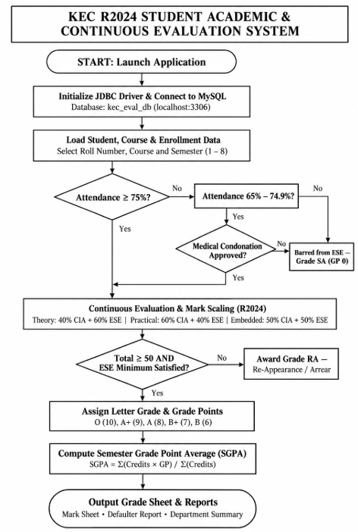

PROCEDURE:

1. Load the MySQL Connector/J driver to enable communication between the Java application and the MySQL database.
2. Establish a database connection to kec_eval_db running on the local MySQL server using DriverManager.getConnection().
3. Add and retrieve student details, including roll number, name, department, and semester, along with course details such as course code, title, credits, and course type.
4. Enroll students in semester courses and record attendance details, including total classes held and classes attended. Calculate the attendance percentage.
5. Verify examination eligibility based on attendance. Students with 75% or above attendance are eligible, while those with 65%–74.9% require approved medical condonation. Students with attendance below 65%, or without required condonation approval, are marked as Shortage of Attendance (SA).
6. Record CIA-1, CIA-2, and assignment, quiz, or laboratory marks in phases. Calculate the internal assessment marks according to the prescribed evaluation weightages.
7. Record end-semester examination (ESE) marks or mark students as absent (AB). Apply the appropriate CIA and ESE weightages and minimum ESE passing requirements for theory, practical, and embedded courses.
8. Calculate the total marks by combining the weighted internal assessment and ESE marks. Assign letter grades and grade points according to the R2024 grading system. Students who fail to meet the minimum passing requirements are assigned Re-Appearance (RA), while attendance shortages and absences are recorded separately.
9. Generate semester grade sheets displaying course details, attendance, marks, grades, grade points, earned credits, and Semester Grade Point Average (SGPA). Calculate the equivalent percentage when the semester evaluation is complete.
10. Generate attendance defaulter reports and department-wise performance summaries, including pass, failure, absence, pending evaluation, and class-average SGPA statistics.
11. Display the processed information through the interactive console application, allowing faculty or administrators to manage student records, update assessments, and generate academic reports.

DATABASE SCHEMA:

- STUDENTS TABLE:
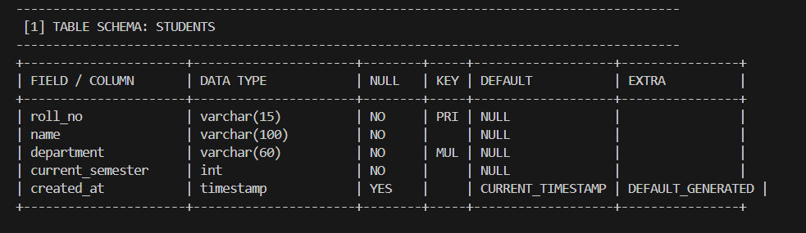

COURSES TABLE:
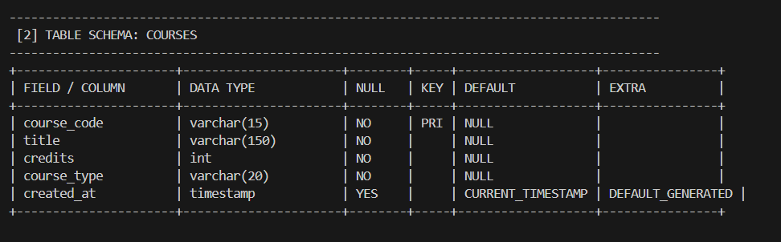

ENROLLMENTS TABLE:

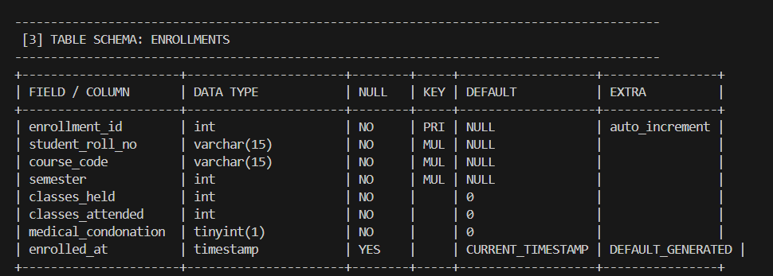

ASSESSMENT MARKS TABLE:
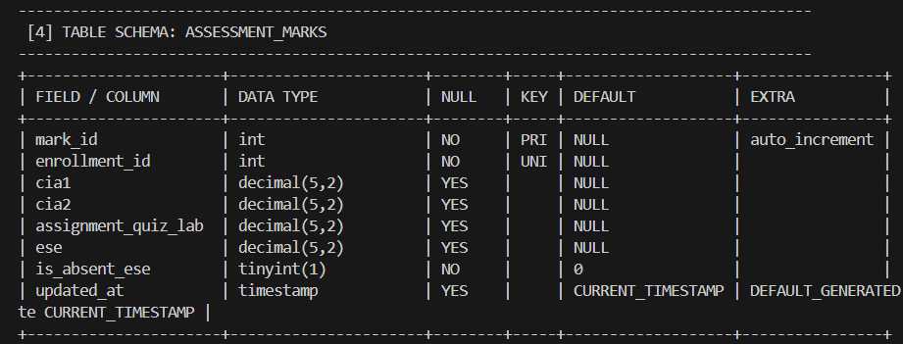
SOURCE CODE: MAINAPP.JAVA:
import java.util.*;

public class MainApp {
static Scanner sc = new Scanner(System.in);
static ArrayList<String> students = new ArrayList<>();
static ArrayList<String> courses = new ArrayList<>();
static ArrayList<String> records = new ArrayList<>();

public static void main(String[] args) {
int choice;
do {
System.out.println("\nKEC STUDENT ACADEMIC SYSTEM");
System.out.println("1. Add Student");
System.out.println("2. View Students");
System.out.println("3. Add Course");
System.out.println("4. View Courses");
System.out.println("5. Record Attendance");
System.out.println("6. Enter Marks");
System.out.println("7. Generate Mark Sheet");
System.out.println("8. Defaulter Report");
System.out.println("9. Department Summary");
System.out.println("0. Exit");
System.out.print("Enter choice: ");
choice = sc.nextInt();
sc.nextLine();

switch (choice) {
case 1: addStudent(); break;
case 2: display(students, "Students"); break;
case 3: addCourse(); break;
case 4: display(courses, "Courses"); break;
case 5: attendance(); break;
case 6: marks(); break;
case 7: display(records, "Mark Sheet"); break;
case 8: defaulterReport(); break;
case 9:
System.out.println("Total Students: " + students.size());
System.out.println("Total Courses: " + courses.size());
break;
case 0: System.out.println("Exiting system..."); break;
default: System.out.println("Invalid choice!");

}
} while (choice != 0);
}

static void addStudent() {
System.out.print("Enter Roll Number: ");
String roll = sc.nextLine();
System.out.print("Enter Student Name: ");
String name = sc.nextLine();
students.add(roll + " - " + name);
System.out.println("Student added successfully!");
}

static void addCourse() {
System.out.print("Enter Course Code: ");
String code = sc.nextLine();
System.out.print("Enter Course Name: ");
String name = sc.nextLine();
courses.add(code + " - " + name);
System.out.println("Course added successfully!");
}

static void display(ArrayList<String> list, String title) {
System.out.println("\n" + title);
if (list.isEmpty()) System.out.println("No records found.");
else for (String item : list) System.out.println(item);
}

static void attendance() {
System.out.print("Enter Student Roll Number: ");
String roll = sc.nextLine();
System.out.print("Classes Held: ");
int held = sc.nextInt();
System.out.print("Classes Attended: ");
int attended = sc.nextInt();
sc.nextLine();

if (held <= 0 || attended < 0 || attended > held) {
System.out.println("Invalid attendance details!");
return;
}

double percentage = attended * 100.0 / held;
System.out.printf("Attendance: %.2f%%\n", percentage);
records.add(roll + " - Attendance: " +
String.format("%.2f%%", percentage));
}

static void marks() {
System.out.print("Enter Student Roll Number: ");
String roll = sc.nextLine();
System.out.print("Enter Course Code: ");
String course = sc.nextLine();
System.out.print("Enter CIA Marks: ");
double cia = sc.nextDouble();
System.out.print("Enter ESE Marks: ");
double ese = sc.nextDouble();
sc.nextLine();

if (cia < 0 || cia > 100 || ese < 0 || ese > 100) {
System.out.println("Invalid marks!");
return;
}

double total = (cia * 0.4) + (ese * 0.6);

String result = total >= 50 ? "PASS" : "FAIL";

records.add(roll + " - " + course + " - Total: " +
total + " - " + result);
System.out.println("Marks recorded successfully!");
}

static void defaulterReport() {
System.out.println("Attendance Defaulter Report");
for (String record : records)
if (record.contains("Attendance:"))
System.out.println(record);
}
}

DB CONNECTION.JAVA:

import java.sql.Connection;
import java.sql.DriverManager;
import java.sql.SQLException;

public class DBConnection {
static final String URL =
"jdbc:mysql://localhost:3306/kec_eval_db";
static final String USER = "root";
static final String PASSWORD = "";

public static Connection getConnection()
throws SQLException {
return DriverManager.getConnection(
URL, USER, PASSWORD);
}

public static boolean testConnection() {
try (Connection con = getConnection()) {
return con != null && !con.isClosed();
} catch (SQLException e) {
System.out.println("Connection failed!");
return false;
}
}

public static void main(String[] args) {
if (testConnection()) {
System.out.println(
"MySQL connected successfully!");
} else {
System.out.println(
"Unable to connect to MySQL.");
}
}
}

OUTPUT SCREENSHOTS:

MAIN MENU:

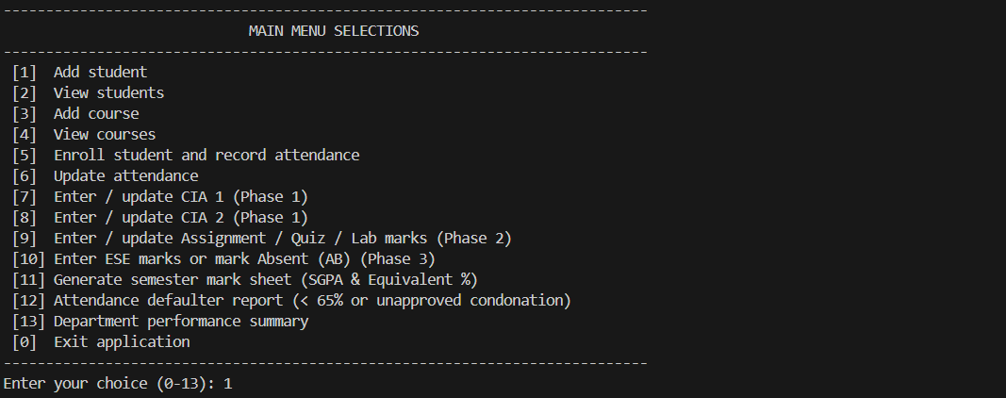

STUDENT & COURSE MANAGEMENT:

STUDENT REGISTRATION:
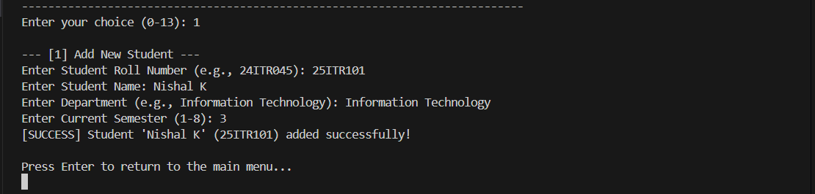

COURSE CATALOG:
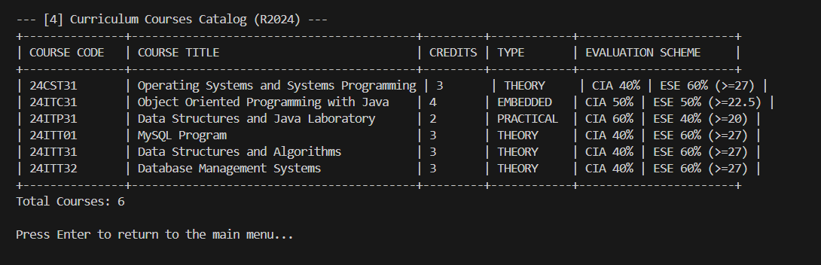

COURSE ENROLLMENT & ATTENDANCE TRACKING:
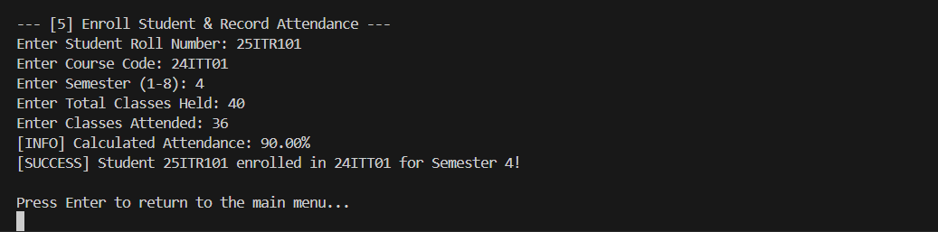

INCREMENTAL MARKS ENTRY:

PHASE 1 (MID-SEMESTER):
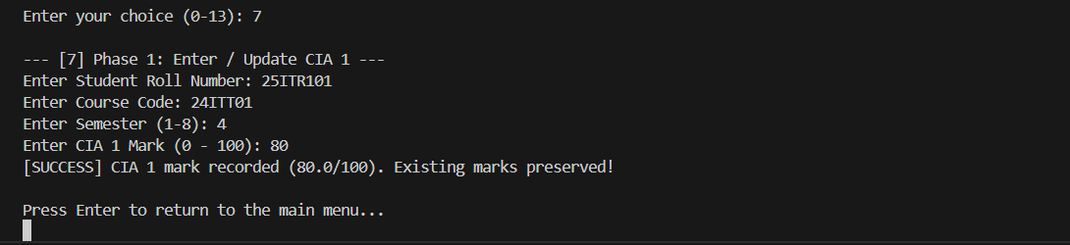

PHASE 2 (END OF SEMESTER - CIA):

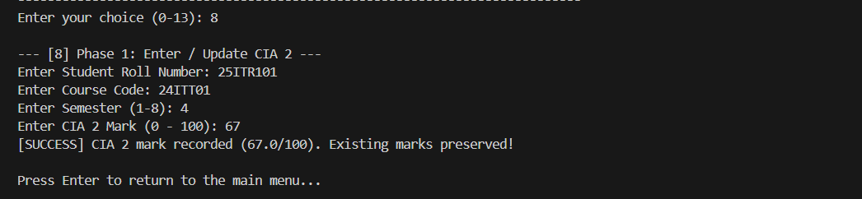

PHASE 3 (POST SEMESTER):

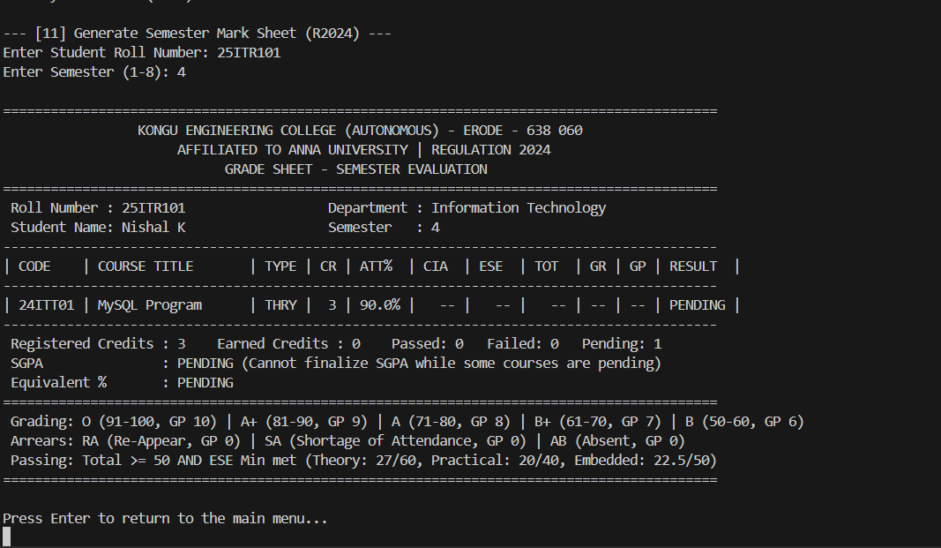

ATTENDANCE & GRADING RULES:

ATTENDANCE FILTER:
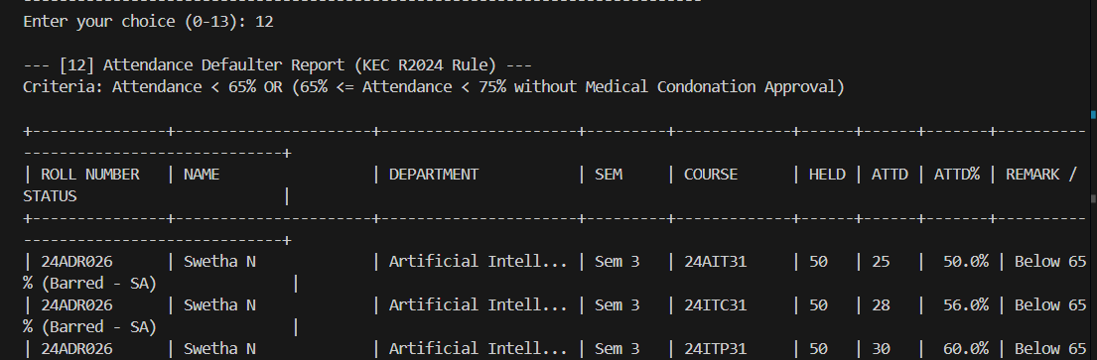

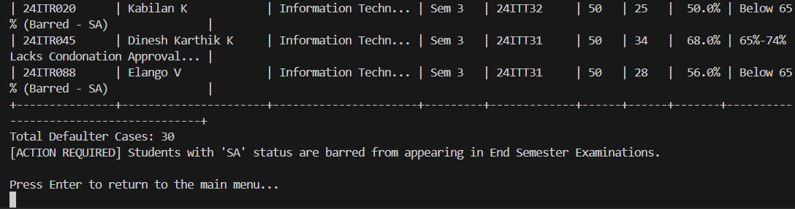

DEPARTMENT WISE CLASS PERFORMANCE & RESULT SUMMARY:

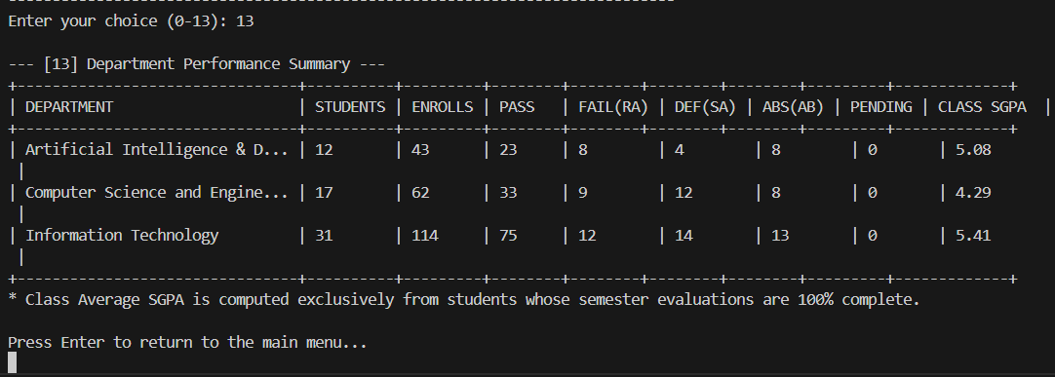

DATABASE:

STUDENTS DATABASE:

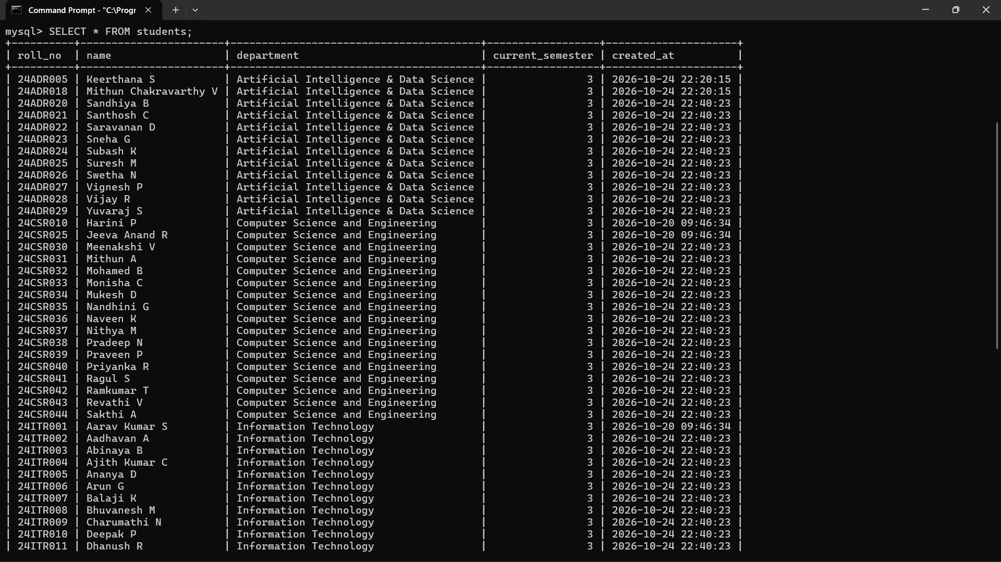

COURSES DATABASE:
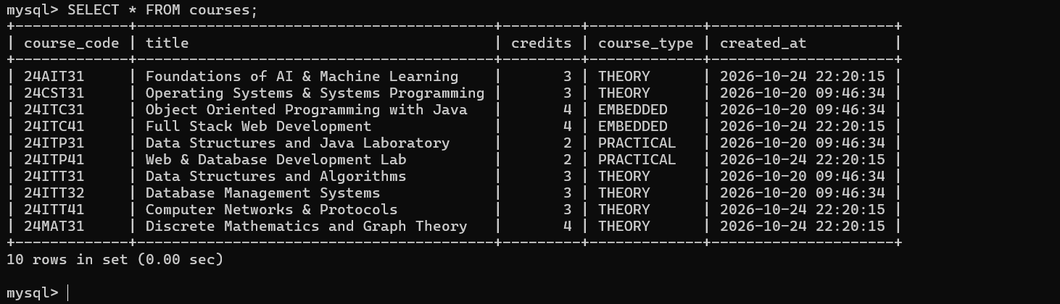

ENROLLMENTS DATABASE:
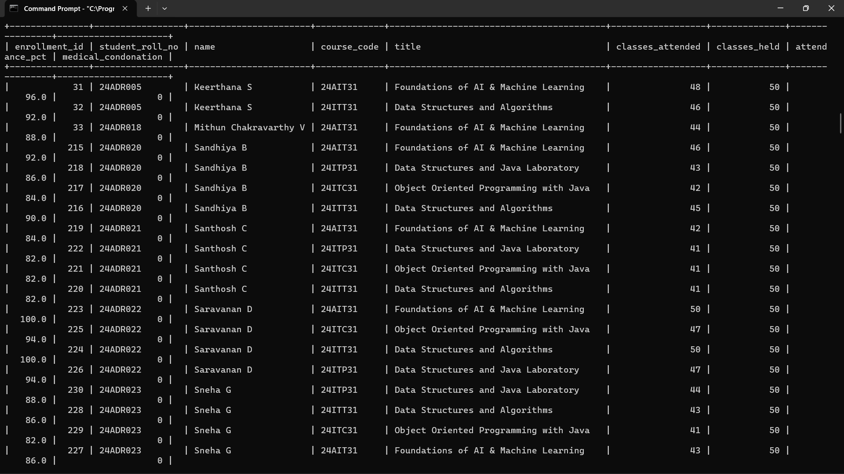

RESULT:

Thus, the Student Academic and Continuous Evaluation System for Kongu Engineering College (Autonomous) Regulation 2024 was successfully designed, developed, and tested using Java (JDBC) and MySQL. The system accurately automates the calculation of Continuous Internal Assessments (CIA), End Semester Examinations (ESE), Letter Grades, Attendance Eligibility, and Semester Grade Point Average (SGPA).

REFERENCES:
- Oracle, Java SE Documentation – JDBC Overview and Architecture. https://docs.oracle.com/javase/8/docs/technotes/guides/jdbc/ .
- Oracle, Java SE API – HttpServer. https://docs.oracle.com/en/java/javase/17/docs/api/jdk.httpserver/com/sun/net/httpserve r/HttpServer.html .
- Oracle, MySQL 8.0 Reference Manual. https://dev.mysql.com/doc/refman/8.0/en/ .

- Oracle, MySQL Connector/J Developer Guide. https://dev.mysql.com/doc/connector-j/8.0/en/ .
- University Grants Commission, Guidelines for Choice Based Credit System (CBCS). https://www.ugc.gov.in/pdfnews/8023719_Guidelines-for-CBCS.pdf .
- Chart.js, Chart.js Documentation. https://www.chartjs.org/docs/latest/ .

- Tailwind CSS, Tailwind CSS Documentation. https://tailwindcss.com/docs .

- GeeksforGeeks, Establishing JDBC Connection in Java. https://www.geeksforgeeks.org/establishing-jdbc-connection-in-java/ .
- YouTube, Java JDBC with MySQL Tutorial Videos. https://www.youtube.com/results?search_query=Java+JDBC+MySQL+tutorial .
- Anthropic, Claude AI Assistant (used for project ideas and guidance). https://claude.ai/ .

GITHUB:

LINK: | https://github.com/pavens25it/KEC-R2024-Student-Evaluation-System

